Test Case: tc001_SPX_Dev5_Crear_Requisicion_Spot_Tipo_Cobro_CC
Step 1 - Enter username and password and click to button Enter : Credentials Entered
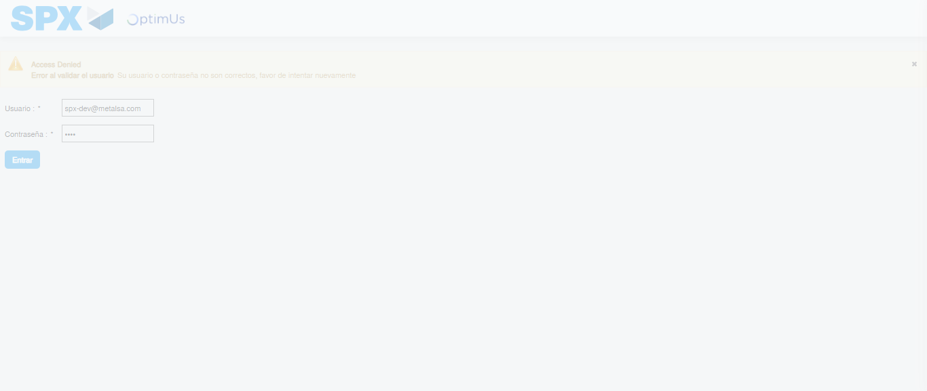Image file-name: QC_Testing-tc001_SPX_Dev5_Crear_Requisicion_Spot_Tipo_Cobro_CC-1783980260919

Step 2 - Select to UEN and Access to Spot Buy Requisitions : UEN Correctly selected and Correct access
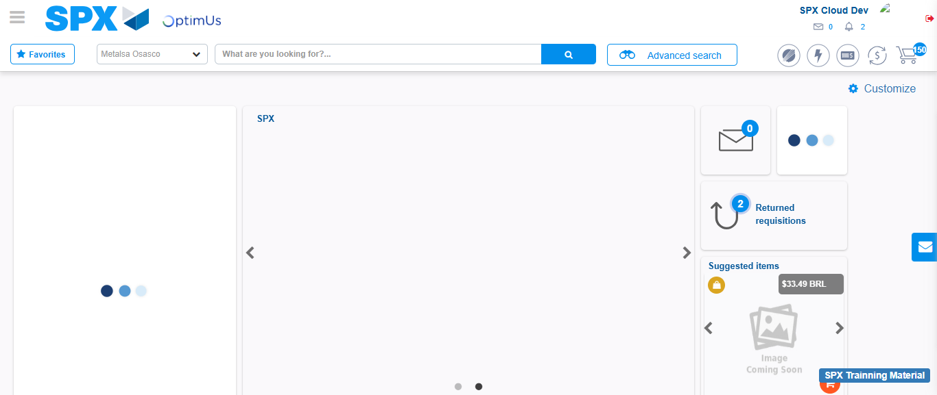Image file-name: QC_Testing-tc001_SPX_Dev5_Crear_Requisicion_Spot_Tipo_Cobro_CC-1783980286880

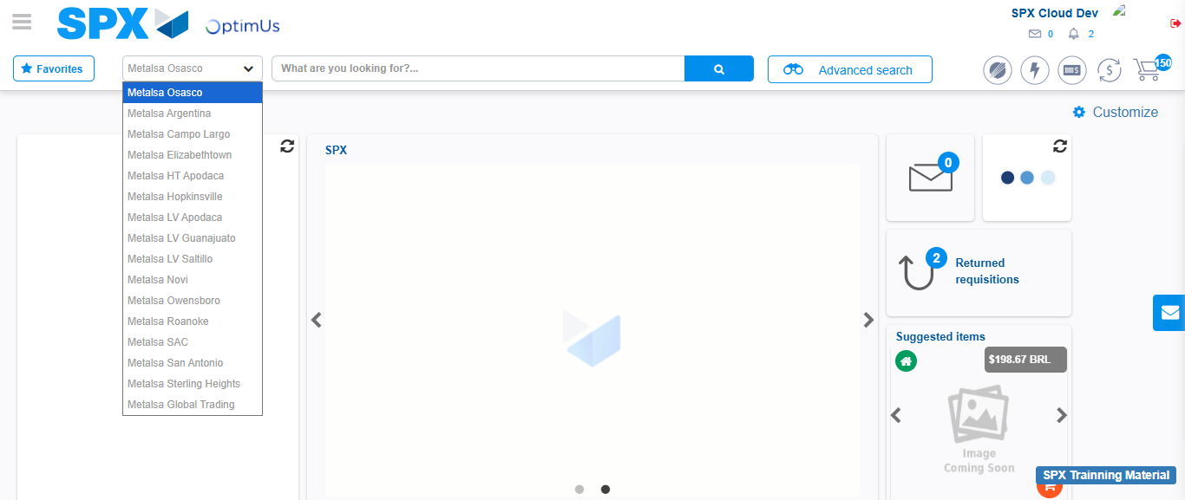Image file-name: QC_Testing-tc001_SPX_Dev5_Crear_Requisicion_Spot_Tipo_Cobro_CC-1783980289451

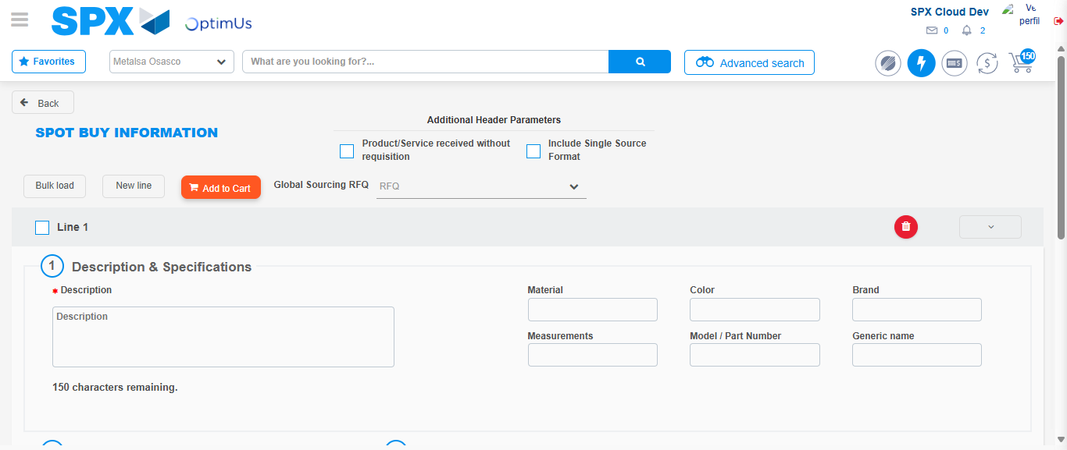Image file-name: QC_Testing-tc001_SPX_Dev5_Crear_Requisicion_Spot_Tipo_Cobro_CC-1783980309684

Step 3 - Data Capture Spot Buy Requisition : Data captured correctly
Image file-name: QC_Testing-tc001_SPX_Dev5_Crear_Requisicion_Spot_Tipo_Cobro_CC-1783980309940

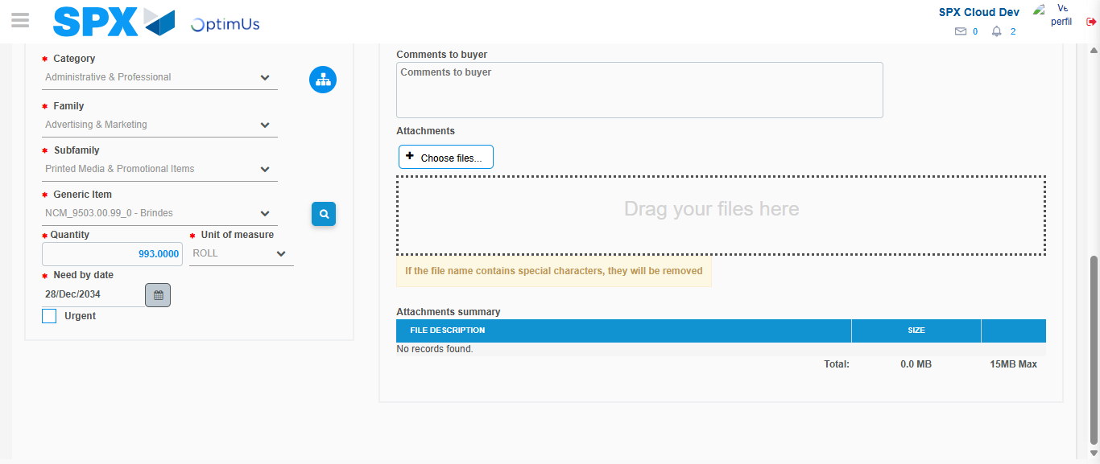Image file-name: QC_Testing-tc001_SPX_Dev5_Crear_Requisicion_Spot_Tipo_Cobro_CC-1783980321788

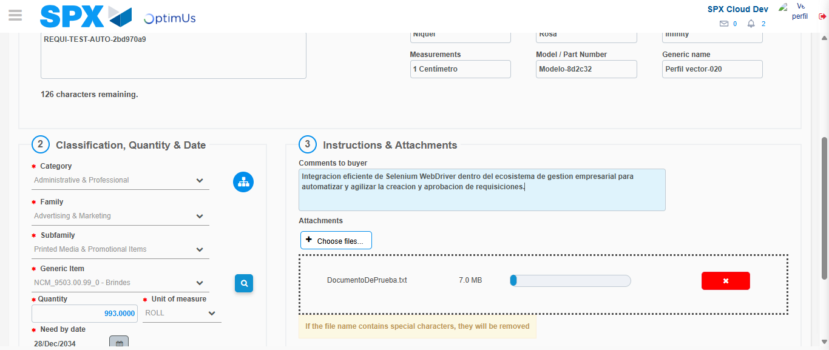Image file-name: QC_Testing-tc001_SPX_Dev5_Crear_Requisicion_Spot_Tipo_Cobro_CC-1783980322564

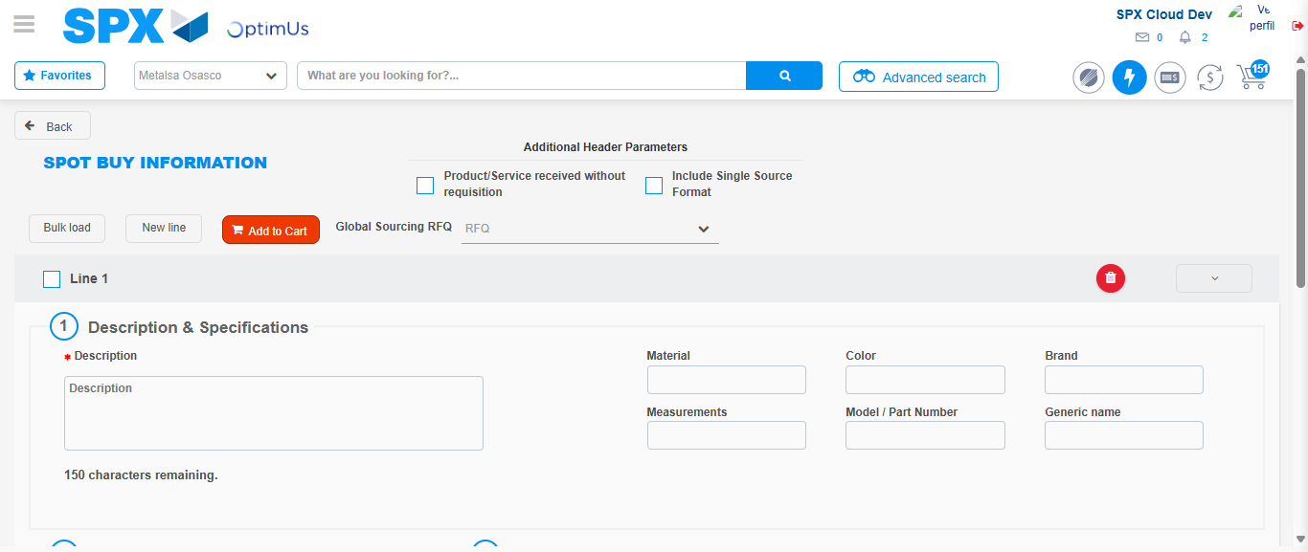Image file-name: QC_Testing-tc001_SPX_Dev5_Crear_Requisicion_Spot_Tipo_Cobro_CC-1783980333020

Step 7 - Return to Main Page SPX : Return to Main Page SPX
Image file-name: QC_Testing-tc001_SPX_Dev5_Crear_Requisicion_Spot_Tipo_Cobro_CC-1783980286880

Image file-name: QC_Testing-tc001_SPX_Dev5_Crear_Requisicion_Spot_Tipo_Cobro_CC-1783980289451

Image file-name: QC_Testing-tc001_SPX_Dev5_Crear_Requisicion_Spot_Tipo_Cobro_CC-1783980309684

Image file-name: QC_Testing-tc001_SPX_Dev5_Crear_Requisicion_Spot_Tipo_Cobro_CC-1783980335252

Image file-name: QC_Testing-tc001_SPX_Dev5_Crear_Requisicion_Spot_Tipo_Cobro_CC-1783980335442

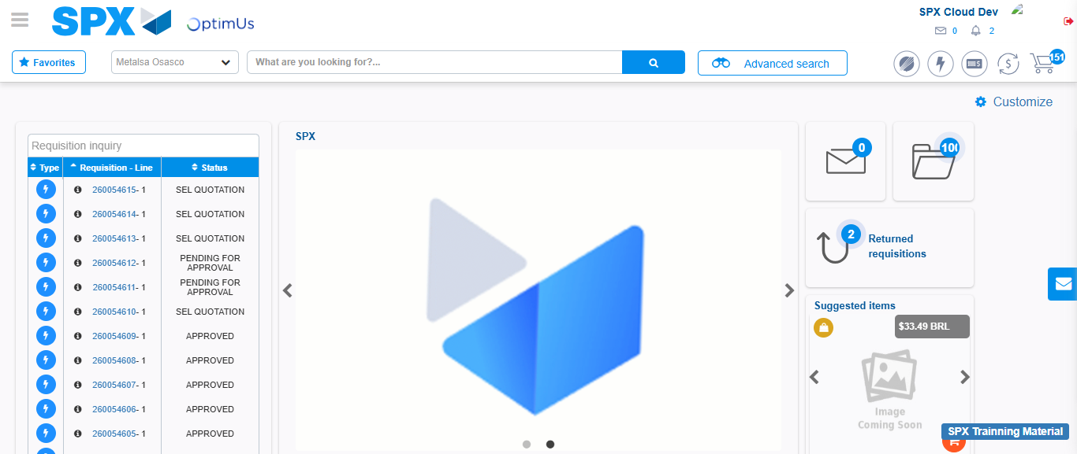Image file-name: QC_Testing-tc001_SPX_Dev5_Crear_Requisicion_Spot_Tipo_Cobro_CC-1783980356428

Step 8 - Log Out : Log Out SPX
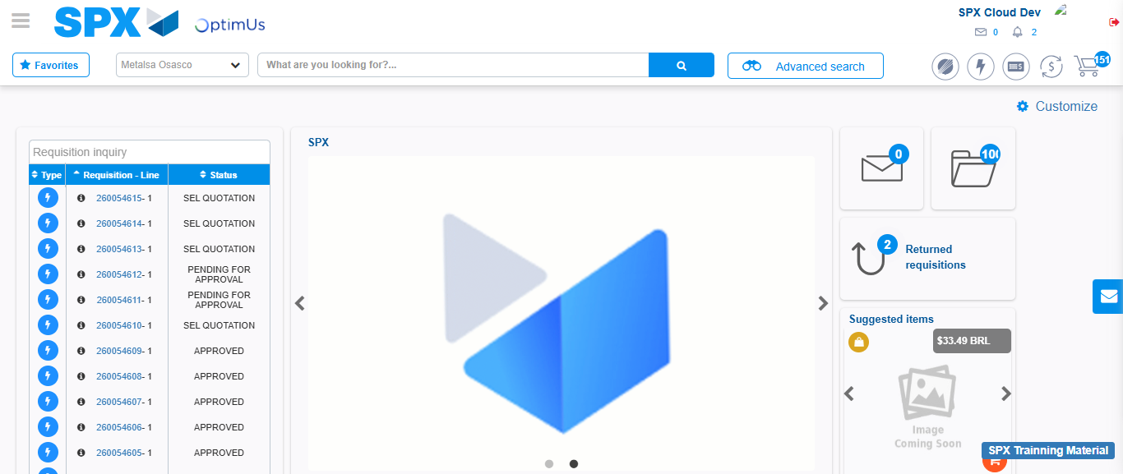Image file-name: QC_Testing-tc001_SPX_Dev5_Crear_Requisicion_Spot_Tipo_Cobro_CC-1783980356736

